**BREAST CANCER DETECTION USING CNN AND ATTENTION MECHANISM**

**A MINOR PROJECT REPORT**

*Submitted by*

**JACOB KEVIN P [Reg No: RA2111030010161]**

**ETHAN RM ASHER [Reg No: RA2111030010163]**

**PAUL BEZALEEL [Reg No: RA2111030010197]**

*Under the Guidance of*

**DR. PRABAKERAN S**

Associate Professor, Department of Networking and Communications

*In partial fulfilment of the requirements for the degree of*

**BACHELOR OF TECHNOLOGY**

**in**

**COMPUTER SCIENCE AND ENGINEERING**

**with a specialization in CYBER SECURITY**



**DEPARTMENT OF NETWORKING AND COMMUNICATION COLLEGE OF ENGINEERING AND TECHNOLOGY SRM INSTITUTE OF SCIENCE AND TECHNOLOGY**

**KATTANKULATHUR – 603 203**

**AUG 2024**

**TABLE OF CONTENTS**

|  |  |  |
| --- | --- | --- |
| **CHAPTER** | **TITLE** | **PAGE. NO** |
| I | ABSTRACT | 3 |
| II | INTRODUCTION | 4 |
| III | LITERATURE REVIEW | 6 |
| IV | SYSTEM ARCHITECTURE | 8 |
| V | REFERENCES | 10 |

**Abstract**

Breast cancer remains one of the most prevalent and lethal forms of cancer among women worldwide, necessitating advancements in diagnostic accuracy and efficiency. This paper presents a comprehensive approach to breast cancer classification using deep learning techniques applied to histopathological images. Traditional diagnostic methods often rely on manual examination of tissue samples, which can be error-prone and time-consuming. To address these challenges, we propose a robust computational framework leveraging convolutional neural networks (CNNs) and attention mechanisms to enhance the precision of breast cancer diagnosis.

Our study utilizes a range of deep learning models, including VGG16, ResNet50, and a novel Squeeze-and-Excitation (SE) ResNet50 network, to classify breast cancer images into benign and malignant categories. By incorporating advanced techniques such as data augmentation, normalization, and transfer learning, our models achieve significant improvements in classification performance. We also explore the effectiveness of attention mechanisms in improving model accuracy, sensitivity, and specificity.

Our experimental results demonstrate that the SE-ResNet50 architecture outperforms other models, achieving an impressive accuracy of 97.34% in predicting affective states related to breast cancer pathology. Additionally, the application of Squeeze-and-Excitation networks further enhances the representational power of the models, providing critical insights into the spatial and channel-wise features of the images. This research underscores the potential of integrating deep learning with advanced image processing techniques to offer more reliable and efficient diagnostic tools for breast cancer.

The proposed framework not only improves diagnostic accuracy but also sets the foundation for future developments in automated cancer detection systems. By advancing the state-of-the-art in computer-aided diagnosis, this work contributes to the broader goal of achieving more precise and timely cancer diagnosis, ultimately supporting better patient outcomes and aligning with global health objectives.

**Introduction**

Breast cancer is a critical global health issue that continues to affect millions of individuals annually. As one of the most prevalent cancers among women, it presents significant challenges not only in terms of patient care but also in the realm of medical research and diagnostic technology. Breast cancer originates in the breast tissues, often starting in the ducts or lobules, and can potentially spread to other parts of the body if not detected and managed promptly. The complexity and variability of breast cancer necessitate advanced and reliable diagnostic methods to improve patient outcomes and survival rates.

Breast cancer is characterized by a range of tumour types and classifications, each with its implications for diagnosis and treatment. The primary classifications include ductal carcinoma in situ (DCIS), which is a non-invasive cancer confined to the ducts; invasive ductal carcinoma (IDC), which is the most common type and begins in the ducts but invades surrounding tissues; and invasive lobular carcinoma (ILC), which starts in the lobules and can also spread to nearby tissues. Additionally, there are several less common types of breast cancer, each with unique features and treatment requirements. Understanding these various types is crucial for developing effective treatment strategies and improving patient prognoses.

Early detection of breast cancer is vital for successful treatment and improved survival rates. Traditional methods of diagnosis include clinical breast examinations, mammography, ultrasound, and magnetic resonance imaging (MRI). Mammography has long been considered the gold standard for breast cancer screening due to its ability to detect tumours before they become palpable. However, mammography has limitations, particularly in dense breast tissues where it may miss smaller or early-stage tumours. As a result, supplementary imaging techniques such as ultrasound and MRI are often used to enhance diagnostic accuracy. Despite these advances, the challenge of differentiating between malignant and benign tumours persists, highlighting the need for more sophisticated diagnostic tools.

The exploration of advanced diagnostic techniques for breast cancer is driven by the need to address several key challenges in the current healthcare landscape. Early detection of breast cancer significantly improves treatment outcomes and patient survival rates. However, the limitations of conventional imaging methods highlight the necessity for more sophisticated approaches. Traditional methods, while effective, can sometimes produce false negatives or positives, which underscores the importance of developing more accurate diagnostic tools.

In recent years, the field of breast cancer diagnosis has seen significant advancements through the application of computer-aided diagnosis systems. These systems use advanced algorithms to analyze medical images, providing valuable assistance to radiologists in identifying and characterizing tumours. The application of machine learning and artificial intelligence (AI) in medical imaging has emerged as a transformative force in healthcare. Machine learning models, particularly deep learning approaches such as CNNs, have shown exceptional promise in automating and enhancing the diagnostic process. These models are trained on vast datasets of medical images to learn complex patterns and features associated with various conditions. The ability of CNNs to automatically extract and learn hierarchical features from images makes them highly suitable for tasks such as tumour detection and classification. By training these models on annotated datasets, researchers can develop systems that assist radiologists in identifying and characterizing tumours more accurately and efficiently.

Attention mechanisms further enhance the capabilities of CNNs by enabling the model to focus on the most relevant parts of an image. This is especially important in medical imaging, where subtle variations in tumour characteristics can significantly impact diagnosis. Attention mechanisms work by assigning different levels of importance to different regions of an image, allowing the model to prioritize areas that are more likely to contain important diagnostic information. This focused approach improves the model's ability to differentiate between benign and malignant lesions and reduces the likelihood of misclassification.

The hybridization of CNNs with attention mechanisms represents a significant advancement in computer-aided diagnosis. By combining these techniques, researchers can leverage the strengths of both approaches to achieve superior performance. Hybrid models integrate the feature extraction capabilities of CNNs with the refined focus provided by attention mechanisms, resulting in a more robust and accurate diagnostic tool. This integration is particularly valuable in the context of breast cancer, where the ability to accurately classify tumours can have a profound impact on patient outcomes.

The development and application of hybrid models that integrate CNNs with attention mechanisms have the potential to transform breast cancer diagnosis. These models leverage the strengths of both approaches, enhancing the model's ability to detect and classify tumours with greater accuracy. By incorporating attention mechanisms, hybrid models can better focus on important regions within an image, leading to improved performance in distinguishing between benign and malignant lesions. This advancement is particularly significant given the challenges associated with traditional imaging techniques and the need for more accurate and reliable diagnostic tools.

In addition to technical advancements, the development of hybrid models is also driven by the need to address broader public health concerns. Breast cancer remains a leading cause of cancer-related deaths globally, with significant variations in incidence and survival rates across different regions. Improving diagnostic accuracy through advanced computational techniques not only contributes to better individual patient care but also has the potential to impact public health on a larger scale. Enhanced diagnostic tools can lead to earlier detection, more effective treatment, and ultimately better survival rates, thereby addressing a critical public health challenge.

The integration of advanced diagnostic technologies aligns with several Sustainable Development Goals (SDGs), including Goal 3: Good Health and Well-Being. The SDGs emphasize the importance of reducing mortality rates and ensuring access to quality healthcare for all individuals. By advancing diagnostic capabilities and improving early detection methods, researchers and healthcare professionals contribute to the achievement of these goals. The development and implementation of hybrid models in breast cancer diagnosis represent a step towards realizing a more equitable and effective healthcare system.

In summary, the integration of advanced computational techniques into breast cancer diagnosis represents a significant advancement in the fight against this pervasive disease. The exploration of advanced diagnostic techniques for breast cancer is driven by the need to address several key challenges in the current healthcare landscape. Early detection of breast cancer significantly improves treatment outcomes and patient survival rates. However, the limitations of conventional imaging methods highlight the necessity for more sophisticated approaches. Traditional methods, while effective, can sometimes produce false negatives or positives, which underscores the importance of developing more accurate diagnostic tools.

Machine learning, particularly through the use of Convolutional Neural Networks (CNNs), offers a promising solution by enhancing the accuracy of image analysis and diagnosis. The incorporation of attention mechanisms further refines these models by enabling them to focus on critical features within images, thus improving diagnostic precision. Hybrid models that combine CNNs with attention mechanisms present a novel approach to overcoming the limitations of existing methods and achieving better performance. These advancements not only contribute to more reliable and earlier detection of breast cancer but also align with broader public health objectives and Sustainable Development Goals (SDGs), aiming to reduce cancer mortality rates and improve overall healthcare outcomes.

**Literature Review**

The advancement in computational techniques for medical image analysis, particularly in breast cancer diagnosis, highlights a significant leap forward in leveraging deep learning models for accurate and efficient classification. This review synthesizes contributions from various studies focusing on convolutional neural networks (CNNs), attention mechanisms, and specialized architectures such as Squeeze-and-Excitation Networks (SENets) and Dual Squeeze and Excitation Networks (DSE Networks), alongside recent findings in affect detection and breast cancer diagnosis.

**Convolutional Neural Networks (CNNs):**

Convolutional neural networks have become a cornerstone in image-based tasks, including medical diagnostics. Alex Krizhevsky et al. and Karen Simonyan et al. were pivotal in developing deep CNN architectures that have since been widely adopted in various applications. Their work set new performance benchmarks, especially in image recognition tasks, paving the way for applying these models to medical image analysis.

In the context of breast cancer, Abdullah-Al Nahid et al. combined CNNs with Recurrent Neural Networks (RNNs) to enhance tissue classification accuracy. They utilized unsupervised learning for image segmentation and achieved an accuracy of 91%. Sabeena Beevi K et al. advanced this approach by using a CNN-based transfer learning technique for mitosis detection, achieving F-scores of 88.6% and 89.66% on the MITOS-ATYPIA-14 and RCC datasets, respectively.

Further studies such as those by Neslihan Bayramoglu et al. demonstrated the efficacy of CNNs in predicting malignancy levels, with accuracies of 83.25% for single-task CNNs and 82.13% for multi-task CNNs. Babak Ehteshami Bejnordi et al. introduced a CNN-based method for classifying whole-slide breast tissue images into categories such as fat, stroma, and epithelium, achieving an area under the ROC curve of 0.921. Meriem Amrane et al. applied AI to clinical breast cancer diagnosis using histopathological images and CNNs, showcasing practical implementations of these models

**Attention Mechanisms:**

Attention mechanisms have further refined deep learning models by enhancing their focus on relevant features within an image. Przystalski et al. explored attention mechanisms in CNNs for breast cancer classification, developing the Attention-Guided Convolutional Network. This network achieved 91.2% accuracy, outperforming standard CNNs. The Convolutional Block Attention Module (CBAM) exhibited superior sensitivity and negative predictive value (NPV), while the Attention-Guided Convolutional Neural Network excelled in precision and specificity.

Soham Chattopadhyay et al. proposed DRDA-Net, a Dense Residual Dual-Shuffle Attention Network, which achieved accuracies ranging from 94.41% to 98.1% on the BreaKHis dataset. This model effectively addressed overfitting and gradient issues, making it particularly advantageous for small datasets. Alaa Hussein Abdulaal et al. improved breast cancer classification using a modified GoogLeNet with an attention mechanism, achieving 98.08% accuracy in binary classification and 94.63% in multi-class classification.

Marcin Ziąber et al. compared different attention mechanisms in CNNs for breast tumor malignancy detection. The Attention Guided Convolutional Neural Network (AGCNN) achieved the highest accuracy (91.2%) and AUC-ROC (96.6%), while the Convolutional Block Attention Module (CBAM) excelled in NPV and sensitivity, reinforcing the value of attention mechanisms in diagnostic applications.

**ResNet-50:**

In the realm of affect detection, Dhananjay Theckedath and R. R. Sedamkar investigated the use of CNNs with transfer learning to detect seven basic affect states. Their study compared VGG16, ResNet50, and SE-ResNet50 networks, with the SE-ResNet50 model integrating the SE block with ResNet50. The results showed validation accuracies of 96.8%, 99.47%, and 97.34% for VGG16, ResNet50, and SE-ResNet50, respectively, with ResNet50 achieving the highest accuracy.

In breast cancer diagnosis, Qasem Abu Al-Haija and Adeola Adebanjo proposed a computational framework using ResNet-50 CNN to classify histopathological images into benign or malignant categories. Their model, leveraging transfer learning with a pre-trained ResNet-50 on ImageNet, achieved an exceptional classification accuracy of 99% on the BreakHis dataset, outperforming other models in the same study.

**Squeeze-and-Excitation Networks (SENets):**

Squeeze-and-Excitation Networks (SENets) have introduced a novel approach to enhancing CNN performance by recalibrating channel-wise feature responses. Hu et al. proposed the Squeeze-and-Excitation (SE) block, which models interdependencies between channels to improve representational power. SENets achieved notable performance improvements with minimal computational overhead, exemplified by their victory in the ILSVRC 2017 classification with a reduced top-5 error rate of 2.251%.

In a related study, Md. Mostafa Kamal Sarker et al. developed an Efficient Breast Cancer Classification Network utilizing Dual Squeeze and Excitation (DSE) blocks. Their method, built upon the EfficientNetV2 backbone, incorporated Fused Mobile Inverted Bottleneck Convolutions (FMB-Conv) and Mobile Inverted Bottleneck Convolutions (MBConv). This approach outperformed ResNet101, InceptionResNetV2, and EfficientNetV2 networks on the BreakHis dataset, demonstrating superior precision, recall, and F1-scores across various magnification levels.

**Conclusion:**

The integration of advanced deep learning techniques, including CNNs, attention mechanisms, SENets, and DSE Networks, has significantly enhanced the accuracy and efficiency of breast cancer diagnosis. The improvements in classification performance and diagnostic capabilities underscore the transformative potential of these technologies in medical image analysis. The continued exploration and application of these techniques are expected to further refine diagnostic tools, offering more reliable and precise solutions for cancer detection and beyond.

**System architecture**

**Class Diagram:**

**Sequence Diagram:**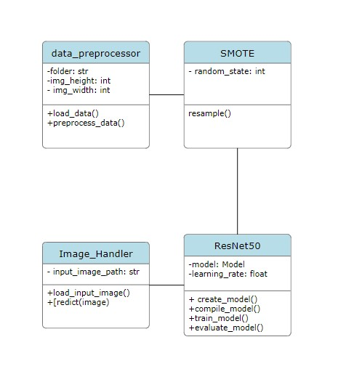

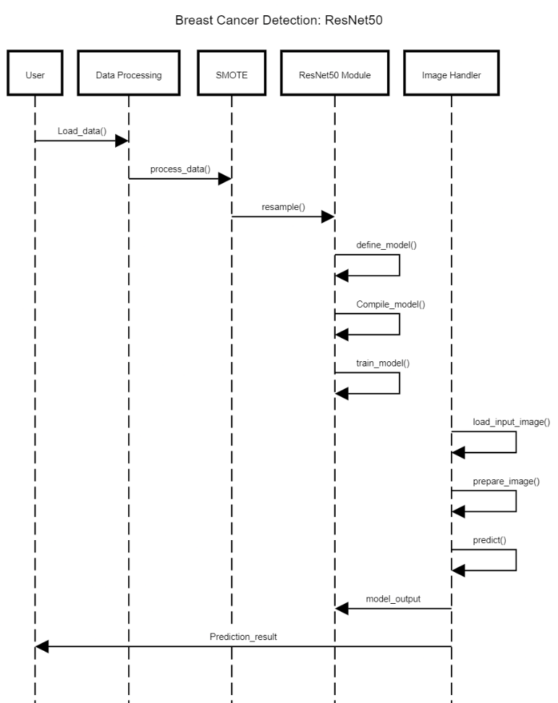

**Activity Diagram:**

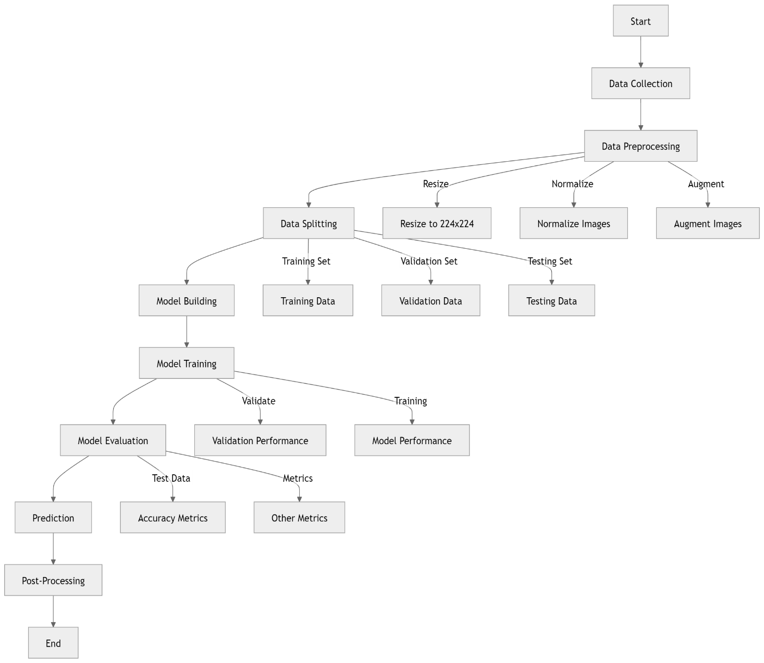

**References**

* Breast Cancer Histopathological Image Classification: A Deep Learning Approach. Authors: Mehdi Habibzadeh Motlagh et al.
* Breast Cancer Classification Using Deep Learning Approaches and Histopathology Image: A Comparison Study. Authors: Faezehsadat Shahidi et al.
* Breast Cancer Histopathology Image Classification Using an Ensemble of Deep Learning Models. Authors: Zabit Hameed et al.
* Squeeze-and-Excitation Networks. Authors: Jie Hu et al.
* Efficient Breast Cancer Classification Network with Dual Squeeze and Excitation in Histopathological Images. Authors: Md. Mostafa Kamal Sarker et al.
* Detecting Affect States Using VGG16, ResNet50 and SE-ResNet50 Networks. Authors: Dhananjay Theckedath & R. R. Sedamkar
* Breast Cancer Diagnosis in Histopathological Images Using ResNet-50 Convolutional Neural Network. Authors: Qasem Abu Al-Haija & Adeola Adebanjo